Software Project Management Plan

Commerce Bank Project – Team 4
February 21, 2020

Team Members
Harrison R. Lara
Daudi Williams
Sung Ho Lee
Madison Hubbard
Osama Esam Obadi AlHaiki

Document Control

Change History
Revision | Change Date | Description of changes
V1.0 | 2/21/2020 | Initial release

Document Storage
This document will be stored and versioned on Github. This can be found at: https://github.com/umkc-cs-451-2020-spring/semester-project-group-4/tree/master/docs

Document Owner
Harrison Lara is responsible for developing and maintaining this document.

Table of Contents
1 Overview 2
1.1 Purpose and Scope 2
1.2 Goals and Objectives 2
1.3 Project Deliverables 3
1.4 Assumptions and Constraints 4
1.5 Schedule and Budget Summary 5
1.6 Success Criteria 6
1.7 Definitions 7
1.8 Evolution of the Project Plan 7
2 Startup Plan 8
2.1 Team Organization 8
2.2 Project Communications 8
2.3 Technical Process 8
2.4 Tools 9
3 Work Plan 9
3.1 Activities, Tasks, and Iteration Plans 9
3.2 Release Plan 10
3.3 Budget 10
4 Control Plan 10
4.1 Monitoring and Control 10
4.2 Project Measurements 11
5 Supporting Process Plans 12
5.1 Risk Management Plan 12
5.2 Configuration Management Plan 12
5.3 Verification and Validation Plan 13
5.4 Product Acceptance Plan 13

Overview

Purpose and Scope
The purpose of this web applications is to allow users to bank and use the services provided by Commerce Bank need a web application to manage their accounts, transactions and notifications. This website will need to use all transactions for a user across several accounts the user has with the bank. The user will also need to be able to customize and have a default set of notifications for transactions, time, dates, balances, etc.

The scope of this project is not limited to but consists of ensuring users will be able to login or register, then be able to navigate to a dashboard that allows them to see notifications and a snapshot of their accounts. From there a user can export account data, view transactions by account and add data. Users will also be able to manage and add notifications. Extra features and user experience will be added if time allows.

Goals and Objectives
The overall goal is to give users a way to manage their accounts, transactions and services with Commerce Bank.
- Provide a login for existing users.
- Provide a registration page for new users.
- Function in a simple and intuitive manner.
- Provide users with balances and transaction details for their saving and checking accounts.
- Provide a way for users to export all their data from each account to excel.
- Allow users to customize, create and manage notifications based on their needs for the different accounts they have.
- Users will be able to add transactions to the desired account.

Project Deliverables

Delivered on or by March 02, 2020 – Iteration 1
- Project Charter
- Requirements Document
- Project Plan
- Base Login Page
- Login Page Validation (email, password)
- Home Page Navigation
- Sign Up Page (first, last, email, username, password)
- Sign Up Page Validation
- Login Page Validation Errors
- Login Page Input Fields and Button (Formik)
- Styling of Login Page (Commerce Bank Theme)
- Login dataflow (UI -> Server -> DB)
- System Testing
- Versioning (features and defects)
- Bug Fixes

Delivered on or by March 16, 2020 – Iteration 2
- Account Balance Components (Dashboard)
- Retrieval of account
- Notification Center on Home Page
- Routes to navigate to each Balance Page
- Checking Page
- Savings Page
- Unit Testing
- System Testing
- Versioning (features and defects)
- Bug fixes

Delivered on or by April 04, 2020 – Iteration 3
- Data Grid for Checking Account Page
- Data Grid for Saving Account Page
- Styling of Home, Checking, Savings Pages (Commerce Bank Theme)
- Ability to Export Data from Grid into CSV (React CSV)
- Filtering and Sorting on Grid
- Acceptance Testing
- Security Scanning and Package Audit (NPM, Black Duck)
- Versioning (features and defects)
- Bug fixes

Delivered on or by April 20, 2020 – Iteration 4
- Ability to Add a Transaction to Savings and Checking Account Pages
- Notification Rules
- Notifications Component
- Ability Remove Notification from Home Screen
- Unit Testing
- Acceptance Testing
- Security Scanning and Package Audit (NPM, Black Duck)
- Versioning (features and defects)
- Bug fixes

Delivered on or by May 04, 2020 – Iteration 5

- Show Notification by Priority on Home Page
- Ability to Add, Edit, Delete Notifications
- Add Styling for Notifications (Commerce Bank Theme)
- Add User Session (Stretch)
- Unit Testing
- Acceptance Testing
- Security Scanning and Package Audit (NPM, Black Duck)
- Versioning (features and defects)
- Bug fixes

Assumptions and Constraints
Assumptions
- All developers will have access to machines to contribute to the project.
- The project requirements will not change or vary much based off the given requirements.
- All team members will commit to their five hours a week and reach out for help.
- There will be some overflow from iterations
- There will be time taken for training on the new technology stack

Constraints
- Team knowledge of a full stack application
- Must be a web application
- Must use a modern front-end technology
- Must include a database
- Must include two stretch tasks
- Some knowledge of web development
- Some knowledge of user experience
- Must be delivered on or by May 04, 2020

Schedule and Budget Summary

- 1 project manager at 5 hours per week for 13 weeks
  - 65 hours * $50/hr = $3,250
- 4 software engineers at 5 hours per week each for 13 weeks
  - 260 hours * $40/hr = $10,400
- 325 hours total
- $13,650 total
- Average of $42.00 per hour
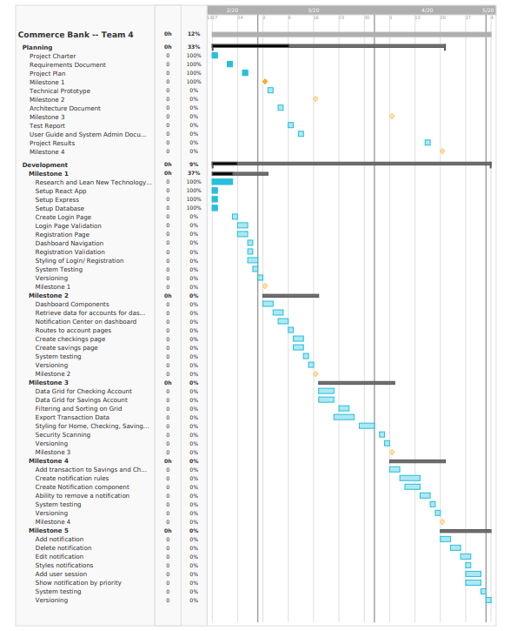

Success Criteria
- All high-priority use cases in the requirements specification are delivered before May 04
- Two of the stretch tasks are met
- The project will be considered a success if the team delivers an operational prototype at the end of the semester with the features mentioned in the goal section above
- 80% or more of the team members would be willing to work together on another software project in the future.
- Commerce Bank is pleased with the functionality and presented result (for the most part).
- All deliverables are on time.

Definitions
Use case – describes a goal-oriented interaction between the system and an actor. A use case may define several variants called scenarios that result in different paths through the use case and usually different outcomes.
Scenario – one path through a use case
Customer/ User – user or other software system that receives value from a use case.
Role – category of users that share similar characteristics.
Product – what is being described here; the software system specified in this document.
Project – activities that will lead to the production of the product described here. Project issues are described in a separate project plan.
Shall – adverb used to indicate importance; indicates the requirement is mandatory. “Must” and “will” are synonyms for “shall”.
Should – adverb used to indicate importance; indicates the requirement is desired but not mandatory.
May – adverb used to indicate an option. Not used to express a requirement, but rather to specifically allow an option.
Controls/ User Experience/ UX – the individual elements of a user interface such as buttons and check boxes.

Evolution of the Project Plan
The entire project has been mapped out by feature and user story from the start so there is an initial understanding of risk, roadblock and time commitment. There has been room adjusted for in iteration 4 and 5 for overflow of stories from iteration 1, 2 and 3. There is room for additional tasks if needed starting halfway though iteration 3.

At the end of every iteration, the project manager will plan the next iteration and evaluate for any risks, roadblocks in the future and determine if the next iteration is obtainable. The team meeting will be held weekly on Monday afternoons to help address any team member issues and questions for each iteration as we plan.

Startup Plan

Team Organization
Project Manager: The project manager is responsible for creating the project plan (with input from those doing the work), managing risks, running the weekly team meeting and providing monthly status reports to senior management.
Programmers (5): Programmers are primary responsible for coding and unit testing modules. They are also expected to take part in architecture planning and review meetings.
Designer: The Designer is responsible for working with the project manager to develop mockups and styles for pages upcoming in the next iteration.
Documentation Engineer:
The documentation Engineering is responsible for maintaining, creating and keeping all paperwork up to do throughout the project.

Project Communications
- GitHub tracks each iterations progress
- GitHub gathers all tasks, features and bugs
  - These are scheduled into iterations
- Main communication is on Slack
- Team meetings and updates on progress, roadblocks, etc in person

Technical Process
- Each iteration allows time for reviewing upcoming risks, iterations, addressing and fixing bugs and system testing. Each iteration will have a version attached to it. Security testing will start to occur at iteration 3 and repeat for each iteration following.
- The first iteration is designed for training and getting the hang of the new technology stack, which allows time for setting up your environment. This also includes setting up the login and registration pages.
- The second iteration is heavier as the dashboard is being created and navigation to account pages are established.
- The third iteration is focused on adding data grids to each account page, styling, exporting transaction data and grid sorting.
- Iteration four lighten up and allows for stories to roll over. This iteration only expects notifications to be setup and display on the dashboard.
- Iteration five is light as well for any additional roll over. This iteration includes more styling, user session, managing notifications.

Tools
- Programming Language – Typescript, JSX, JavaScript
- Version Control – source code and written artifacts will be stored in a GitHub
- VS Code – Preferred IDE, but developer’s choice.
- Defect tracking – defects and issues will be tracked using GitHub Issues.
- Build tools – local and main builds will be done using NPM Build.
- Automated testing – unit tests will be implemented with the Jest testing framework.

Work Plan

Activities, Tasks, and Iteration Plans

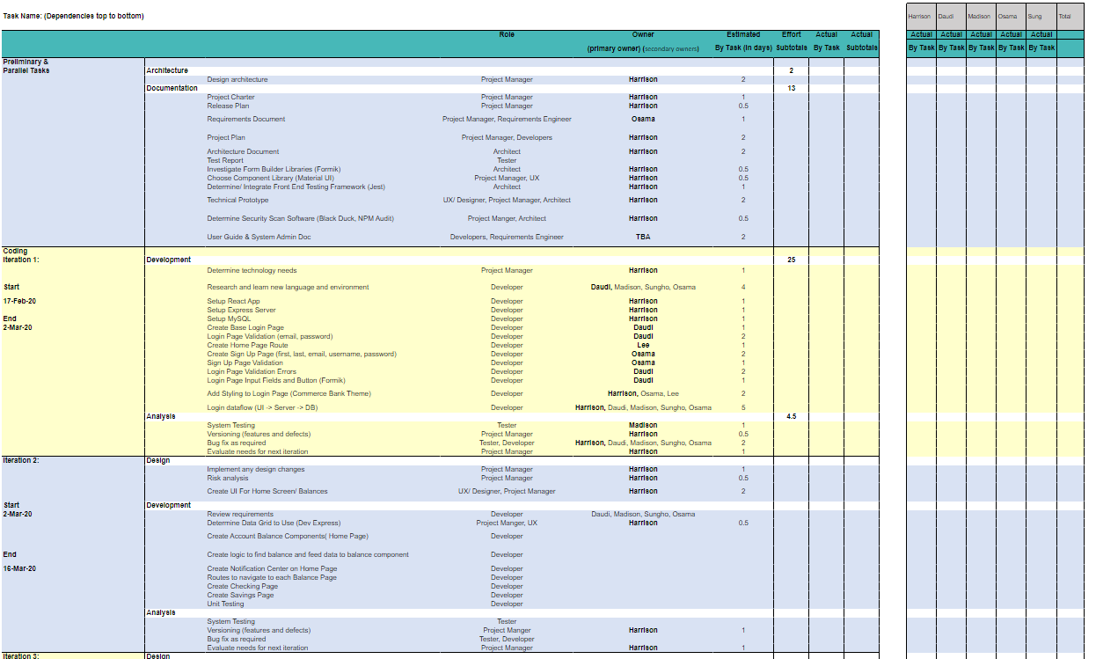
The images below represent the plan for each iteration (dates on left side), how features, defects, testing and versioning will be handled throughout the project. Documentation will be captured and sprinkled throughout each iteration, all is expected to be done by iteration four.
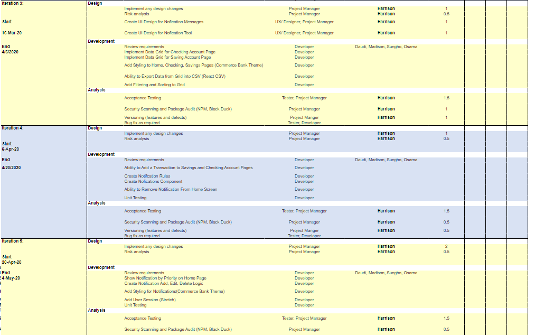

Release Plan
There is a planned release schedule for each iteration. Each iteration will be considered a minor version bump which includes new features that are not breaking changes. If breaking changes are going to occur, then a major version bump will occur. All defects will be captured in patch releases. When the project is completed, a major version bump will occur.

Budget

- 1 project manager at 5 hours per week for 13 weeks
  - 65 hours * $50/hr = $3,250
- 4 software engineers at 5 hours per week each for 13 weeks
  - 260 hours * $40/hr = $10,400
- 325 hours total
- $13,650 total
- Average of $42.00 per hour

Control Plan

Monitoring and Control

- Weekly meetings will occur on Monday afternoons
  - These meetings will be mainly for answering questions, resolve roadblocks and misunderstandings.
  - Planning will be minor
  - Add any additional tasks for future iteration or current iteration if needed
- At the end of every iteration, the project manager will review the iteration and upcoming iteration to make sure progress is on track and mitigate any roadblocks or risks.
- A retrospective will occur at the start of iteration three to make sure we can address any issues and bumps the team has been running into so we can have a cleaner last three iterations.
- The project manager and technical lead will meet during iteration four and five to discuss final preparation tasks for presentations and the project. Dates are TBA.
- Project must be submitted by May 04, 2020
- Presentation will be held on May 04 or May 06, 2020
- Commerce Bank Presentation will be on May 08, 2020

Project Measurements

Phase | Measurement | Source
Release Planning | Record effort estimates for product features | Project Manager
Iteration Planning | Record effort estimates for scheduled tasks  Update effort estimates for product features  Update estimated dates in release plan | Mgr
Iteration Closeout | Record actual effort for scheduled tasks  Record actual effort for product features  Record LOC count for modules written | Project Manager, Devs.
System Test | Record the rate at which errors are found.  Throughouly step through a production environment and look for defects and user experience issues. | QA
Versioning | Version the repository for defects, iterations, breaking changes, final production release | Project Manager
Project Closeout | Archive project performance data in process database. (See process database definition for a list of measures to record.) | Project Manager
Ongoing | Record defects found from integration testing through first year of release.  Assign each defect to one of the following categories: blocker, critical, major, minor or trivial. Keep track of the state of each defect: open, assigned, fixed, closed. | Project Manager /Devs/QA

Supporting Process Plans

Risk Management Plan
- Low level understanding of web development and full stack applications
  - We have allowed half of the first iteration for training and learning the new technology stack.
- If developers struggle with participating, meetings will be held to understand where there is an issue, misunderstanding or how we can get everyone on board.
- Developers being stuck on an issue for too long
  - We encourage all developers to reach out for help on a task they are stuck on after a couple hours. There is no reason to waste days without asking for help.
- If developers struggle with communication, then the developer will be asked to have a meeting and find out why they are not contributing or participating in project communication.

Configuration Management Plan
Configuration management plans for this document and other baselined work products including review procedures and change management procedures.

- Component names will be named as following
  - test-component.tsx
- Test files will follow two conventions
  - Test-component.spec.tsx
  - Routes.spec.tsx

- All project (work products) items (documents, source code, test cases, program data, test data, etc.) will be stored in the GitHub repository including the project plan, charter, etc.

- All tasks and code will be reviewed at the time of a Pull Request and also the features developed during an iteration will be demoed at the end of an iteration to determine if changes need to be made.

- If someone wants to make a change that is outside of a ticket and its acceptance criteria, then a poll or questions can be asked inside Slack. If most of the group think this change is in best favor of the project and does not involve a lot of time/ put the iteration timeline at risk, then the developer can make the change. If there is not enough time in the iteration, then the change will be logged in a ticket and placed in the next iteration. All members are encouraged to share their opinions and thoughts during the project.

- All changes going into GitHub must follow the PR standards, Bug and Feature templates that have been setup on GitHub.

Verification and Validation Plan
The quality of the project is taken very seriously. Each PR must be reviewed code wise and also pulled down and tested before being merged to master. At the end of each iteration, there is a task for system testing which allows for a developer and/or several developers walk through a production environment which has all changes and additions from the iteration. This allows for the project to seem like a holistic piece and we can log defects from there.

Product Acceptance Plan
Assuming that 5.3 Verification and Validation Plan is followed, there will be an additional final walkthrough of the product before the final release. Any defects and changes will be made before release. All feature and tasks will have listed acceptance criteria that must be meet before the task is considered done and can be merged/ pass code review. Defects that are logged must follow a specific template explaining why, where and how the defect was found and reproduced.

